Zlatka Ciorica

DVD library – JAVA

Contents

1.UML Design 1

2. Plan with Classes, methods with methods included 2

3. MVC design pattern 3

4.References: 3

5.Assignment 2 - Requirements 4

# 1.UML Design

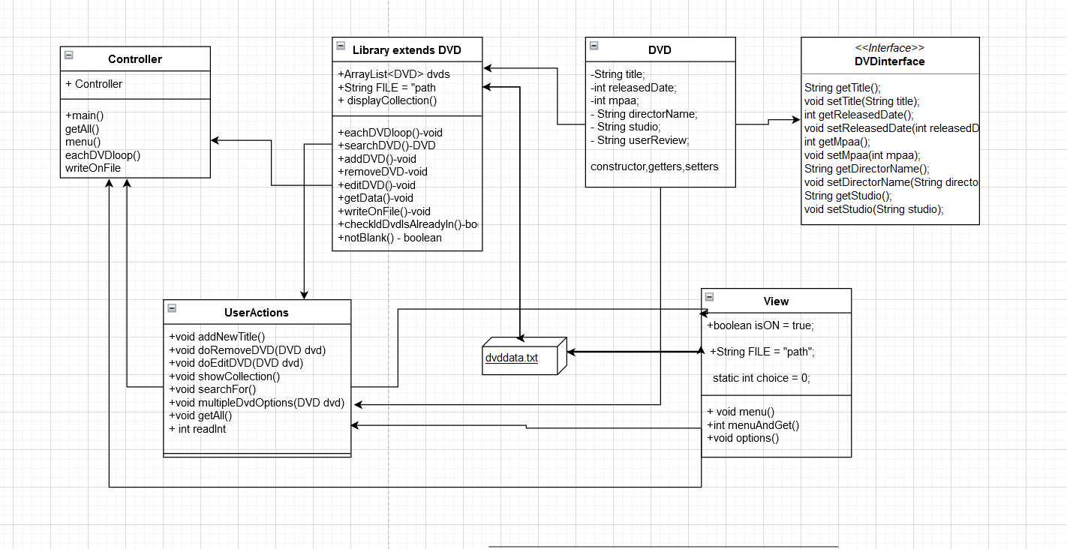

# 2. Plan with Classes, methods with methods included

# 3. MVC design pattern

# 4.References:

Java File Class:

<https://www.programiz.com/java-programming/file#:~:text=The%20file%20object%20is%20linked%20with%20the%20specified,file%20is%20created%20and%20this%20message%20is%20shown>.

Code along Class Roster:

<https://academy.engagelms.com/mod/book/view.php?id=131632>

Delimiter and split in JAVA:

<https://www.javatpoint.com/how-to-split-a-string-in-java-with-delimiter>

<https://www.java67.com/2015/07/how-to-append-text-to-existing-file-in-java-example.html>

# 5.Assignment 2 - Requirements

In this assessment, you will create a program that stores information about a DVD collection.

The program must do the following:

1. Allow the user
   * + - 1. to add a DVD to the collection
         2. remove a DVD from the collection
         3. edit the information for an existing DVD in the collection
         4. to list the DVDs in the collection
         5. display the information for a particular DVD
         6. to search for a DVD by title
2. Load the DVD library from a file
3. Save the DVD library back to the file when the program completes
4. Allow the user to add, edit, or delete many DVDs in one session

Additionally, the program must follow the MVC design pattern and use dependency injection as shown in the course material.

You should follow the process outlined in the *Agile Approach Checklist for Console Applications* document elsewhere in this course.

|  |  |
| --- | --- |
| **Variable** | **Datatype** |
| Title | String |
| Release date | Date / String |
| MPAA rating | Int / String / char |
| Director's name | String |
| Studio | String |
| User rating or note | String |
| DVDS | Static Arraylist |

Your DVD data transfer object

should have the following fields: